**Write a program to present an address book app that enables you to browse existing entries, add new entries and search for entries with a specific last name using prepared statements.**

**STEPS INVOLVED:**

* Creating a main java file which is connected with other base files
* Creating base files add, delete, search and print
* Adding select options to select as per user need
* Creating contact file where the data gets stored

**CODES:**

**Main.java:**

package mainpackage;

import java.util.Arrays;

import java.util.Scanner;

import mainpackage.Print;

import mainpackage.Add;

import mainpackage.Search;

import mainpackage.Change;

import mainpackage.Delete;

import java.io.*;

import java.net.*;

import java.util.*;

import java.nio.charset.Charset;

public class Main {

public static void main(String[] args) throws IOException {

Scanner input = new Scanner(System.in);

int exit = 0;

int answer;

//we will loop until user wants to exit the application

do {

System.out.println("--------Welcome to Address Book---------");

System.out.println("Enter '1' to Add contact");

System.out.println("Enter '2' to Search contact");

System.out.println("Enter '3' to Print contact");

System.out.println("Enter '4' to Edit contact");

System.out.println("Enter '5' to Delete contact");

System.out.println("Enter '0' to Exit");

System.out.println("Do you want to print contacts, add contact, search for contact, edit contact or delete contact?");

System.out.println("Answer with '1', '2', '3', '4', '5' or '0' to exit application.");

try {//we handle the input of the user

answer = input.nextInt();

} catch (NumberFormatException e) {

//e.printStackTrace();

answer = -1;

}

if(answer == 1)//according to user's input we go to each class

Add.add_contact();

else if(answer == 2)

Search.choose_field();

else if(answer == 3)

Print.show_contacts();

else if(answer == 4)

Change.choose_field();

else if(answer == 5)

Delete.choose_field();

}while(answer != exit);

System.out.println("Application terminating...");

}

}

**Add.java:**

package mainpackage;

import java.util.*;

import java.util.Arrays;

import java.io.*;

import java.net.*;

import java.nio.charset.Charset;

import java.io.BufferedReader;

import java.io.File;

import java.io.FileNotFoundException;

import java.io.FileReader;

import java.io.FileWriter;

import java.io.IOException;

import java.io.Writer;

import java.util.Scanner;

public class Add extends Main{

public static void add_contact() throws IOException, FileNotFoundException{

File file1 = new File(System.getProperty("user.dir")+"/Address_Book/src/contacts.txt");// we get the file

BufferedReader reader1 = new BufferedReader(new FileReader(file1)); // we get reader for the file

OutputStreamWriter writer1 = new OutputStreamWriter(

new FileOutputStream(System.getProperty("user.dir")+"/Address_Book/src/contacts.txt", true), "UTF-8");

BufferedWriter writer = new BufferedWriter(writer1);//this is a way to get a writer for th specific file

Scanner input= new Scanner(System.in);

boolean duplicate, valid;

String currentLine1;

String f1 = "";//I initialize the variables to avoid errors

String f2 = "";

String f5 = "";

String f6 = "";

String f8 = "";

int f3 = -10;

int f4 = -11;

int f7 = -1;

int f9 = -1;

String str;

System.out.println("Give Name: ");

f1 = input.nextLine();

System.out.println("Give Surname: ");

f2 = input.nextLine();

do {//this is a do-while loop in which I check for valid input (must me integer) and i loop through the txt file again to check if input is duplicate

duplicate = false;

valid = true;

System.out.println("Give Landline: ");

//f3 = input.nextInt();

try {

f3 = Integer.parseInt(input.nextLine());

} catch (NumberFormatException e) {

valid = false;

System.out.println("Landline must be a valid number.");

//e.printStackTrace();

}

while((currentLine1 = reader1.readLine()) != null) {//check for duplicate

String[] words1=currentLine1.split(",");

if(words1[2].equals(String.valueOf(f3))) {

duplicate=true;

System.out.println("Landline must be unique among the contacts.");

}

}

reader1 = new BufferedReader(new FileReader(file1));

}while (duplicate == true || valid == false);

do {

duplicate = false;

valid = true;

System.out.println("Give Mobile phone: ");

//f4 = input.nextInt();

try {

f4 = Integer.parseInt(input.nextLine());

} catch (NumberFormatException e) {

//e.printStackTrace();

System.out.println("Mobile phone must be number.");

valid = false;

}

while((currentLine1 = reader1.readLine()) != null) {//check for duplicate

String[] words1=currentLine1.split(",");

if(words1[3].equals(String.valueOf(f4))) {

duplicate=true;

System.out.println("Mobile Phone must be unique among the contacts.");

}

}

reader1 = new BufferedReader(new FileReader(file1));

}while (duplicate == true || valid == false);

do {

duplicate = false;

System.out.println("Give E-mail: ");

f5 = input.nextLine();

while((currentLine1 = reader1.readLine()) != null) {//check for duplicate

String[] words1=currentLine1.split(",");

if(words1[4].equals(f5)) {

duplicate=true;

System.out.println("E-mail must be unique among the contacts.");

}

}

reader1 = new BufferedReader(new FileReader(file1));

}while (duplicate == true);

System.out.println("Give Street: ");

f6 = input.nextLine();

System.out.println("Give street number: ");

//f7 = input.nextInt();

do {

valid = true;

try {

f7 = Integer.parseInt(input.nextLine());

} catch (NumberFormatException e) {

//e.printStackTrace();

System.out.println("Street number must be a number.");

valid = false;

}

}while(valid == false);

System.out.println("Give town: ");

f8 = input.nextLine();

System.out.println("Give Zip code: ");

//f9 = input.nextInt();

do {

valid = true;

try {

f9 = Integer.parseInt(input.nextLine());

} catch (NumberFormatException e) {

//e.printStackTrace();

System.out.println("Zip code must be a number.");

valid = false;

}

}while(valid == false);

if(f1 == "" || f2 == "" || f5 == "" || f6 == "" || f8 == "" || f3 == -1 || f4 == -1 || f7 == -1 || f9 == -1) {//i check that all variables have a valid attribute assigned

System.out.println("You gave false inputs, adding new contact wasn't successful: ");

}

else {//if everything is correct i build a string

str = f1 + "," + f2 + "," + String.valueOf(f3) + "," + String.valueOf(f4) + "," + f5 + "," + f6 + "," + String.valueOf(f7) + "," + f8 + "," + String.valueOf(f9);

PrintWriter out = new PrintWriter(new BufferedWriter(new FileWriter(file1, true)));//with these code I add a line at the bottom of the file

out.println(str);

out.close();

}

//input.close();

//writer1.close();

writer.close();

reader1.close();

}

}

**Search.java:**

package mainpackage;

import java.util.*;

import java.util.Arrays;

import java.io.*;

import java.net.*;

import java.nio.charset.Charset;

import java.io.BufferedReader;

import java.io.File;

import java.io.FileNotFoundException;

import java.io.FileReader;

import java.io.FileWriter;

import java.io.IOException;

import java.io.Writer;

import java.util.Scanner;

public class Search {

public static void choose_field() throws FileNotFoundException, IOException {

Scanner input = new Scanner(System.in);

int exit = 0;

int answer;

//we will loop until user wants to exit the application

do {

System.out.println("Do you want to search beased on name or based on phone?");

System.out.println("Give '1' or '2' or anser '0' to return to main menu.");

try {

answer = input.nextInt();

} catch (Exception e) {

answer = 0;

}

if(answer == 1)//according to user's input i go to the correct method

name_search();

else if(answer == 2)

number_search();

}while(answer != exit);

}

public static void name_search() throws IOException, FileNotFoundException{

Scanner input= new Scanner(System.in);

String f1,f2;

System.out.println("Give Name: ");

f1 = input.nextLine();

System.out.println("Give Surname: ");

f2 = input.nextLine();

File file = new File(System.getProperty("user.dir")+"/Address_Book/src/contacts.txt");

BufferedReader reader = new BufferedReader(new FileReader(file));

String currentLine;

boolean first = false;

String[] fields = new String[0];

while((currentLine = reader.readLine()) !=null) {

if(!first) {

fields = currentLine.split(",");

first = true;

}

else {//if both fields that the user gave match a contact i show contact's info

String[] info=currentLine.split(",");

if(info[0].equals(f1) && info[1].equals(f2)) {

System.out.println("----There is a contact for the information you gave----");

for (int i = 0; i < fields.length; i++ ) {

System.out.println(fields[i] +": "+ info[i]);

}

}

else if(info[0].equals(f1) && !info[1].equals(f2)) {//if one of the fields that the user gave match a contact i show contact's info

System.out.println("----There is a contact for the Name you gave----");

for (int i = 0; i < fields.length; i++ ) {

System.out.println(fields[i] +": "+ info[i]);

}

}

else if(!info[0].equals(f1) && info[1].equals(f2)) {//if one of the fields that the user gave match a contact i show contact's info

System.out.println("----There is a contact for the Surname you gave----");

for (int i = 0; i < fields.length; i++ ) {

System.out.println(fields[i] +": "+ info[i]);

}

}

}

}

System.out.println("-------------------");

reader.close();

choose_field();

}

public static void number_search() throws IOException, FileNotFoundException{

Scanner input= new Scanner(System.in);

int f1 = -1;

int f2 = -1;

boolean valid;

System.out.println("Give Phone number: ");

do {//this is a do-while loop in which I check for valid input (must me integer)

valid = true;

try {

f1 = Integer.parseInt(input.nextLine());

} catch (NumberFormatException e) {

//e.printStackTrace();

System.out.println("Phone number must be number.");

valid = false;

}

}while(valid == false);

System.out.println("Give mobile number: ");

do {

valid = true;

try {

f2 = Integer.parseInt(input.nextLine());

} catch (NumberFormatException e) {

//e.printStackTrace();

System.out.println("Mobile number must be number.");

valid = false;

}

}while(valid == false);

File file = new File(System.getProperty("user.dir")+"/src/contacts.txt");

BufferedReader reader = new BufferedReader(new FileReader(file));

String currentLine;

boolean first = false;

String[] fields = new String[0];

if(f1 == -1 && f2 == -1) {

System.out.println("-------------------");

System.out.println("You gave wrong information.");

}

else {

while((currentLine = reader.readLine()) !=null) {

if(!first) {

fields = currentLine.split(",");

first = true;

}

else {//if any of the user's inputs match a contact i show the contact's info

String[] info=currentLine.split(",");

if(f1 == -1 && f2 != -1) {

if(info[3].equals(String.valueOf(f2))) {

System.out.println("----There is a contact for the Mobile number you gave----");

for (int i = 0; i < fields.length; i++ ) {

System.out.println(fields[i] +": "+ info[i]);

}

}

}

else if(f1 != -1 && f2 == -1) {

if(info[2].equals(String.valueOf(f1))) {

System.out.println("----There is a contact for the Phone number you gave----");

for (int i = 0; i < fields.length; i++ ) {

System.out.println(fields[i] +": "+ info[i]);

}

}

}

else if (f1 != -1 && f2 != -1) {

if(info[2].equals(String.valueOf(f1)) && info[3].equals(String.valueOf(f2))) {

System.out.println("----There is a contact for the Phone and Mobile number you gave----");

for (int i = 0; i < fields.length; i++ ) {

System.out.println(fields[i] +": "+ info[i]);

}

}

else if(info[2].equals(String.valueOf(f1)) && !info[3].equals(String.valueOf(f2))) {

System.out.println("----There is a contact for the Phone number you gave----");

for (int i = 0; i < fields.length; i++ ) {

System.out.println(fields[i] +": "+ info[i]);

}

}

else if(!info[2].equals(String.valueOf(f1)) && info[3].equals(String.valueOf(f2))) {

System.out.println("----There is a contact for the Phone number you gave----");

for (int i = 0; i < fields.length; i++ ) {

System.out.println(fields[i] +": "+ info[i]);

}

}

}

}

}

}

System.out.println("-------------------");

reader.close();

choose_field();

}

}

**Print.java:**

package mainpackage;

import java.util.*;

import java.util.Arrays;

import java.io.*;

import java.net.*;

import java.nio.charset.Charset;

import java.io.BufferedReader;

import java.io.File;

import java.io.FileNotFoundException;

import java.io.FileReader;

import java.io.FileWriter;

import java.io.IOException;

import java.io.Writer;

import java.util.Scanner;

public class Print extends Main{

public static void show_contacts() throws IOException, FileNotFoundException{

File file = new File(System.getProperty("user.dir")+"/Address_Book/src/contacts.txt");//we get the contact file

System.out.println(file.getAbsolutePath());

System.out.println(file.getParentFile());

System.out.println(file.exists());

file.createNewFile();

BufferedReader reader = new BufferedReader(new FileReader(file));

String currentLine;

boolean first = false;

String[] fields = new String[0];

while((currentLine = reader.readLine()) !=null) {//for each line in txt file

if(!first) {//if it is the first line the line is the fields and we save them into an array

fields = currentLine.split(",");

first = true;

}

else {//for the rest lines we print the information

System.out.println("-------------------");

String[] info=currentLine.split(",");

for (int i = 0; i < fields.length; i++ ) {

System.out.println(fields[i] +": "+ info[i]);

}

}

}

System.out.println("-------------------");

reader.close();

}

}

**Delete.java:**

package mainpackage;

import java.io.*;

import java.nio.file.DirectoryNotEmptyException;

import java.nio.file.Files;

import java.nio.file.NoSuchFileException;

import java.util.ArrayList;

import java.util.List;

import java.util.Scanner;

public class Delete {

public static void choose_field() throws FileNotFoundException, IOException {

Scanner input = new Scanner(System.in);

int exit = 0;

int answer;

//we will loop until user wants to exit the application

do {//according to user's input i go to the correct method

System.out.println("Do you want to delete a contact based on the name or the phone number?");

System.out.println("Give '1', '2' or '0' to go back to main menu.");

try {

answer = input.nextInt();

} catch (Exception e) {

answer = 0;

}

if(answer == 1)

name_search();

else if(answer == 2)

number_search();

}while(answer != exit);

}

public static void name_search() throws IOException, FileNotFoundException{

Scanner input= new Scanner(System.in);

String f1,f2;

System.out.println("Give Name: ");

f1 = input.nextLine();

System.out.println("Give Surname: ");

f2 = input.nextLine();

File file = new File(System.getProperty("user.dir")+"/Address_Book/src/contacts.txt");

BufferedReader reader = new BufferedReader(new FileReader(file));

String currentLine;

boolean first = false;

String[] fields = new String[0];

List<String> lines = new ArrayList<String>();

while((currentLine = reader.readLine()) !=null) {

if(!first) {

fields = currentLine.split(",");

first = true;

}

else {// only if both of the user's inputs (name and surname) match a contact then i add this contact's info to an array

String[] info=currentLine.split(",");

if(info[0].equals(f1) && info[1].equals(f2)) {

System.out.println("----There is a contact for the information you gave----");

for (int i = 0; i < fields.length; i++ ) {

System.out.println(fields[i] +": "+ info[i]);

}

//contact_change(currentLine);

lines.add(currentLine);

}

else if(info[0].equals(f1) && !info[1].equals(f2)) {

System.out.println("----There is a contact for the Name you gave----");

for (int i = 0; i < fields.length; i++ ) {

System.out.println(fields[i] +": "+ info[i]);

}

System.out.println("----Name ans Surname must be valid----");

}

else if(!info[0].equals(f1) && info[1].equals(f2)) {

System.out.println("----There is a contact for the Surname you gave----");

for (int i = 0; i < fields.length; i++ ) {

System.out.println(fields[i] +": "+ info[i]);

}

System.out.println("----Name and Surname must be valid----");

}

}

}

System.out.println("-------------------");

reader.close();

for(Object str:lines){//for every contatc that i found that is a match

contact_delete(str.toString());

}

choose_field();

}

public static void number_search() throws IOException, FileNotFoundException{

Scanner input= new Scanner(System.in);

int f1 = -1;

int f2 = -1;

boolean valid;

System.out.println("Give Phone number: ");

do {

valid = true;

try {

f1 = Integer.parseInt(input.nextLine());

} catch (NumberFormatException e) {

//e.printStackTrace();

valid = false;

}

}while(valid == false);

System.out.println("Give Mobile number: ");

do {

valid = true;

try {

f2 = Integer.parseInt(input.nextLine());

} catch (NumberFormatException e) {

//e.printStackTrace();

valid = false;

}

}while(valid == false);

File file = new File(System.getProperty("user.dir")+"/src/contacts.txt");

BufferedReader reader = new BufferedReader(new FileReader(file));

String currentLine;

boolean first = false;

String[] fields = new String[0];

if(f1 == -1 && f2 == -1) {

System.out.println("-------------------");

System.out.println("You gave wrong information.");

}

else {

while((currentLine = reader.readLine()) !=null) {

if(!first) {

fields = currentLine.split(",");

first = true;

}

else {

String[] info=currentLine.split(",");

if(f1 == -1 && f2 != -1) {

if(info[3].equals(String.valueOf(f2))) {

System.out.println("----There is a contact for the Mobile number you gave----");

for (int i = 0; i < fields.length; i++ ) {

System.out.println(fields[i] +": "+ info[i]);

}

System.out.println("----Phone and Mobile numbers must be valid----");

}

}

else if(f1 != -1 && f2 == -1) {

if(info[2].equals(String.valueOf(f1))) {

System.out.println("----There is a contact for the Phone number you gave----");

for (int i = 0; i < fields.length; i++ ) {

System.out.println(fields[i] +": "+ info[i]);

}

System.out.println("----Phone and Mobile numbers must be valid----");

}

}

else if (f1 != -1 && f2 != -1) {

if(info[2].equals(String.valueOf(f1)) && info[3].equals(String.valueOf(f2))) {

System.out.println("----There is a contact for the information you gave----");

for (int i = 0; i < fields.length; i++ ) {

System.out.println(fields[i] +": "+ info[i]);

}

contact_delete(currentLine);

}

else if(info[2].equals(String.valueOf(f1)) && !info[3].equals(String.valueOf(f2))) {

System.out.println("----There is a contact for the Phone number you gave----");

for (int i = 0; i < fields.length; i++ ) {

System.out.println(fields[i] +": "+ info[i]);

}

System.out.println("----Phone and Mobile numbers must be valid----");

}

else if(!info[2].equals(String.valueOf(f1)) && info[3].equals(String.valueOf(f2))) {

System.out.println("----There is a contact for the Mobile number you gave----");

for (int i = 0; i < fields.length; i++ ) {

System.out.println(fields[i] +": "+ info[i]);

}

System.out.println("----Phone and Mobile numbers must be valid----");

}

}

}

}

}

System.out.println("-------------------");

reader.close();

choose_field();

}

public static void contact_delete(String line) throws IOException, FileNotFoundException{

File file1 = new File(System.getProperty("user.dir")+"/src/contacts.txt");

BufferedReader reader1 = new BufferedReader(new FileReader(file1));

String currentLine1;

boolean first = false;

String[] fields = new String[0];

File file2 = new File(System.getProperty("user.dir")+"/src/contactstemp.txt");//i create a temporary file to save the changes

BufferedWriter writer = new BufferedWriter(new FileWriter(file2));

while((currentLine1 = reader1.readLine()) !=null) {

if(!first) {

fields = currentLine1.split(",");

writer.write(currentLine1 + "\n");

first = true;

}

else if(!currentLine1.equals(line)){//if the current line in the reader is not the one we want to delete we write it to the temp file

writer.write(currentLine1 + "\n");

}

}

reader1.close();

writer.close();

file1.delete();//we delete the original file

file2.renameTo(file1);//we rename the temporary file to the original file's name

System.out.println("Information was valid, deletion completed successfully");

}

}

**Contacts.txt:**

Name,Surname,Phone,Mobile,E-mail,Street,Number,Town,Zip

shankar,shan,44242334,999999999,shan@gmail.com,chennai,12,tamilnadu,627002

chandru,chand,44213234,987456321,chanddru@gmail.com,anna street,12,chennai,627004

**OUTPUT:**

Adding a contact

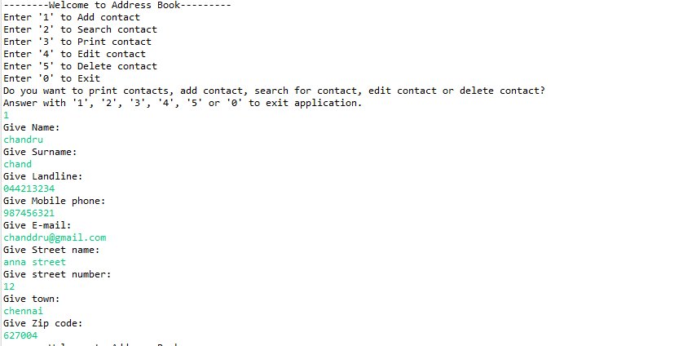

Printing all contacts

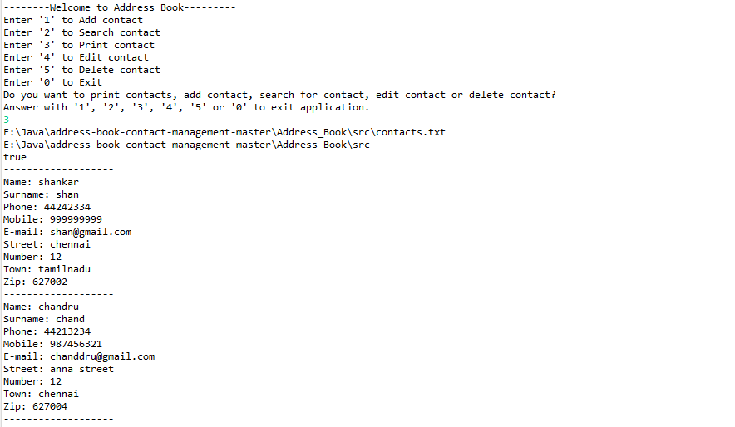

Printing contacts as per user request

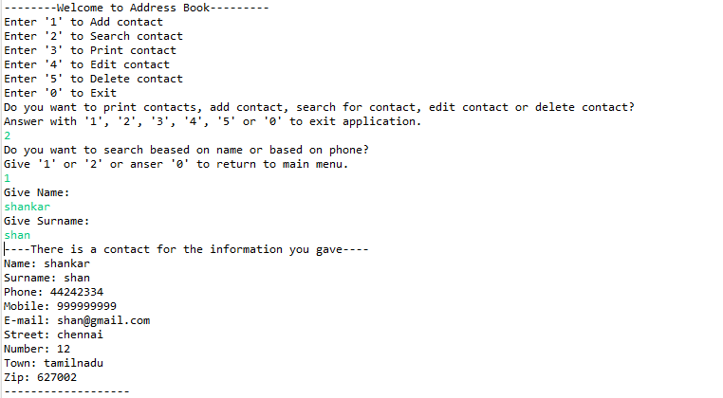

Deleting contact

